
SRM Institute of Science and Technology
SET D
College of Engineering and Technology
School of Computing
SRM Nagar, Kattankulathur – 603203, Chengalpattu District, Tamilnadu
Academic Year: 2022-23 (Even)
Test: CLA-T2 Date: 04-04-2023
Course Code & Title: 18CSC304J & Compiler Design Duration: 1 hour 40 min
Year & Sem: III Year / VI Sem Max. Marks: 50

Course Articulation Matrix: (to be placed)
S.No. | Course  Outcome | PO1 | PO2 | PO3 | PO4 | PO5 | PO6 | PO7 | PO8 | PO9 | PO10 | PO11 | PO12 | PSO1 | PSO2 | PSO3
1 | CO3 | 3 | 3 | 3

Part – A
(10 x 1 = 10 Marks)
Instructions: Answer all
Q. No | Question | Marks | BL | CO | PO | PI Code
1 | Given the following expression grammar:  E -> E * F | F + E | F  F -> F - F | id  which of the following is true?  - * has higher precedence than +  - - has higher precedence than *  - +' has higher precedence  - +' has higher precedence than *  ANS :B | 1 | L1 | 3 | 2 | 2.1.1
2 | Which of the following derivations does a bottom up parser use while parsing an input string?  - Leftmost derivation  B. Leftmost derivation in reverse  C. Rightmost derivation  D. Rightmost derivation in reverse  ANS :D | 1 | L1 | 3 | 2 | 2.1.1
3 | Among simple LR (SLR), canonical LR, and look-ahead LR (LALR), which of the following pairs identify the method that is very easy to implement and the method that is the most powerful, in that order?  - SLR, LALR  - Canonical LR, LALR  - SLR, canonical LR  - LALR, canonical LR  ANS :C | 1 | L1 | 3 | 2 | 2.1.2
4 | Which of the following is correct?  - r? = r . R  - r? = r / έ  - r? = r / r*  - r? = r . r*  ANS :B | 1 | L2 | 3 | 2 | 2.1.2
5 | A form of recursive-descent parsing that does not require any back-tracking is known as?  - predictive parsing  B. non-predictive parsing  C. recursive parsing  D. non-recursive parsing  ANS :A | 1 | L2 | 3 | 2 | 2.1.2
6 | A programmer, by mistake, writes an instruction to divide, instead of a multiply, such error can be detected by a/an  - Compiler  - Interpreter  - Linker  - Not by Compiler/ Interpreter/ Linker  ANS :D | 1 | L2 | 3 | 1 | 1.6.1
7 | Which one of the following is TRUE at any valid state in shift-reduce parsing?  A. Viable prefixes appear only at the bottom of the stack and not inside  B. Viable prefixes appear only at the top of the stack and not inside  C. The stack contains only a set of viable prefixes  D. The stack never contains viable prefixes  ANS :C | 1 | L2 | 3 | 2 | 2.6.1
8 | A Choose a correct statement after left factoring A-> aA’/€  A. A’ -> AB/A/b  B. A’ -> AB/A/€  C. A -> AB/A/a/b  D. Left factoring cannot be done  ANS :B | 1 | L1 | 3 | 2 | 2.6.1
9 | Consider the grammar ,  X → a  X → Y  Z → d  Z → X Y Z  Y → c  Y → ε  Identify the FIRST(Y)  A. {$}  B. { c, ε }  C. { a, c, ε }  D. { c}  ANS :B | 1 | L2 | 3 | 2 | 2.1.2
10 | Consider the augmented grammar given :  S' → S  S → 〈L〉 | id  L → L,S | S  Let I0 = CLOSURE ({[S' → ●S]}). The number of items in the set GOTO (I0 , 〈 ) is: _____.  A. 5  B. 4  C. 3  D. 1  ANS :A | 1 | L1 | 3 | 2 | 2.1.1

11.
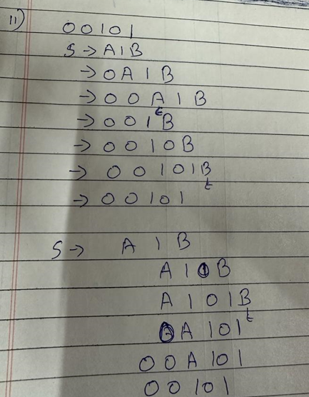
12.
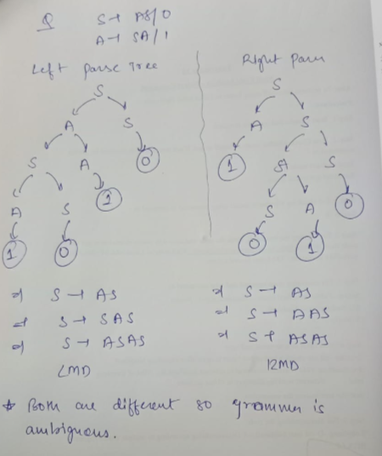
13.
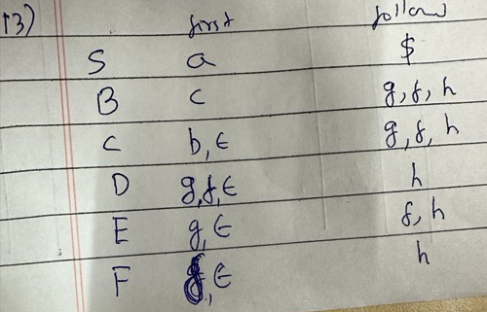

14,15

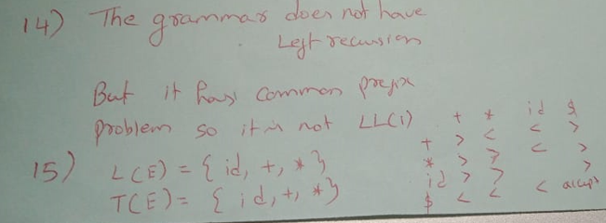
16
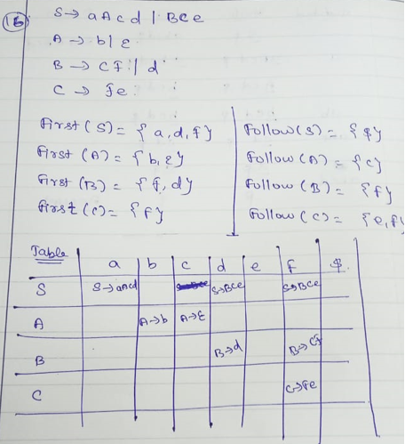
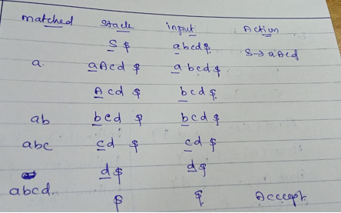
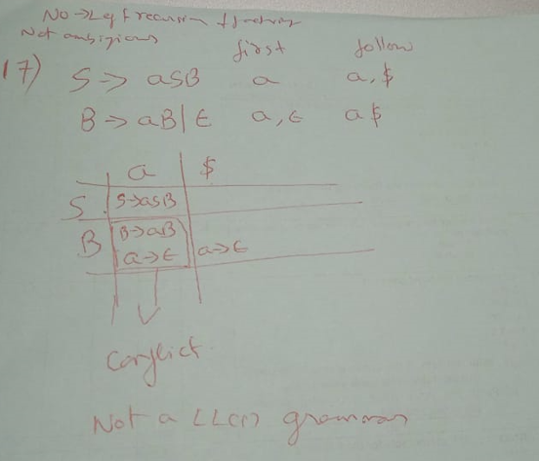

18
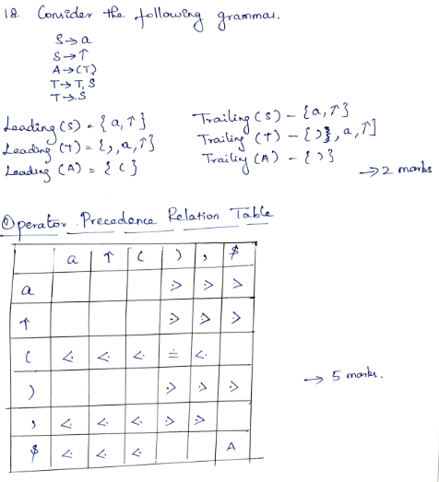
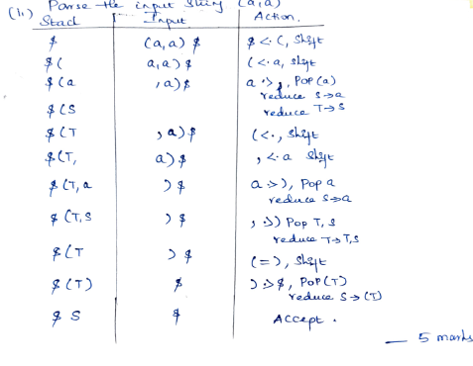
19
